
Lesson 13 Teacher's Key: A Hit That Reacts
Godot Engine - Instructor Reference Only
VIDEO GAME CREATION

What This Lesson Teaches
Using Godot 4's await keyword to pause a single function mid-execution without freezing anything else - a genuinely new language feature this course hasn't needed until now, introduced because this is the first moment a function needs to do something, then wait, then finish.

Level 1 - Full Worked Solution
- await get_tree().create_timer(0.1).timeout pauses ONLY this specific call of _on_area_entered() - every other node, script, and function in the game keeps running normally.
- The explosion is instantiated and added to the scene BEFORE the await, so it starts playing out immediately and independently, with its own Timer managing its own cleanup.
- destroyed.emit() stays unchanged from Lesson 4/7 and runs BEFORE the await, so score/wave/win-check happen at exactly the same instant as last week. Only queue_free() moves to after the await - that is the one and only line actually delayed.
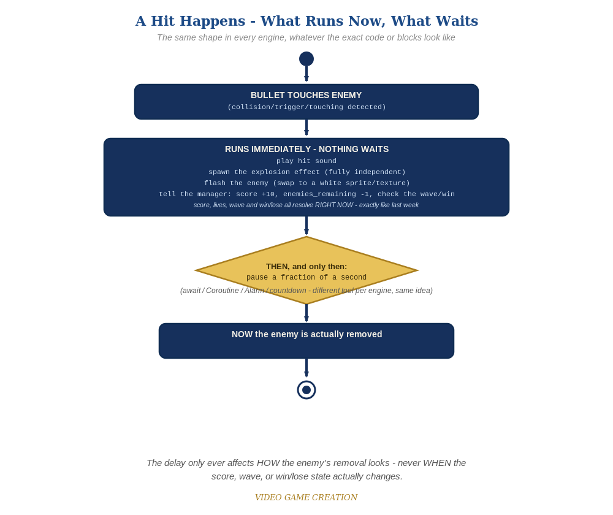
Everything in the top box happens the instant the hit is detected. Only the enemy's own removal - the very last step - waits for the pause to finish.

Why This Structure
- await is the right tool here specifically because the pause needs to happen INSIDE an existing function, without duplicating or restructuring the surrounding collision-detection code - a much smaller change than GameMaker or TIC-80 need for the same idea, since GDScript supports pausing execution directly.
- Giving the explosion its own scene with its own Timer (rather than having the Enemy manage the explosion's lifetime) keeps every object responsible for cleaning up only itself - the same discipline bullets and enemies have followed all course.
- The flash swaps texture rather than tinting modulate white, for the same reason Lesson 2's Recolor swaps sprites instead of tinting them: modulate multiplies against the sprite's existing color, and multiplying any color by white is a no-op - our enemy sprite is opaque red, so a white modulate tint would produce zero visible change.

Level 2 / Level 3 Talking Points
- Ask students to explain, in their own words, why await here doesn't freeze the whole game the way a bug sometimes might - because it only pauses the specific function call it's written inside, not the entire engine.
- For students comparing engines: point out that Unity's Coroutine and Godot's await solve the identical problem (pause mid-function) with similar underlying mechanisms, while GameMaker and TIC-80 need a genuinely different structural approach (splitting into two events/checks) because their languages don't support pausing mid-script at all.

Common Student Mistakes
- Forgetting the await keyword and just calling get_tree().create_timer(0.1).timeout without it - this creates the timer but doesn't actually pause anything, so the function continues immediately.
- Instantiating the explosion AFTER the await instead of before, delaying the visual effect for no reason.
- Not guarding against a second bullet hitting the same enemy while it's mid-await, causing a double-destroyed.emit() call - freeing the bullet immediately (before the await) is what prevents this.

